**Week 4**

Front-End Web UI Frameworks and Tools: Bootstrap 4

**Week 4**

Discuss this week's modules here.

3043 threads · Last post 4 hours ago

[Go to forum](https://www.coursera.org/learn/bootstrap-4/discussions/weeks/4)

**Web Tools**

https://d3njjcbhbojbot.cloudfront.net/api/utilities/v1/imageproxy/https:/coursera-instructor-photos.s3.amazonaws.com/c5/b6cf60386611e5a935a59c4b6594da/muppala-small.jpg?auto=fit&dpr=1&w=40&h=40&fit=crop

Jogesh K. Muppala

This module rounds out our discussions on Bootstrap JavaScript components. Then we discuss CSS preprocessors, Less and Sass. Finally, we discuss building and deployment of our Web projects through task automation using NPM scripts, and task runners like Grunt and Gulp. The final assignment of this course needs to be completed at the end of this module.

**Less**

**Learning Objectives**

* Write Bootstrap JS component controls using jQuery and JavaScript
* Develop CSS code using preprocessors like Less and Sass
* Develop task automation using NPM Scripts
* Formulate task automation using Task runners like Grunt and Gulp

**Less**

**Bootstrap and JQuery**

**[Reading:](https://www.coursera.org/learn/bootstrap-4/supplement/sVpOL/bootstrap-and-jquery-objectives-and-outcomes)**[Bootstrap and JQuery: Objectives and Outcomes](https://www.coursera.org/learn/bootstrap-4/supplement/sVpOL/bootstrap-and-jquery-objectives-and-outcomes)

[. Duration:10 min](https://www.coursera.org/learn/bootstrap-4/supplement/sVpOL/bootstrap-and-jquery-objectives-and-outcomes)

**[Video:](https://www.coursera.org/learn/bootstrap-4/lecture/OaEAe/bootstrap-and-jquery)**[LectureBootstrap and JQuery](https://www.coursera.org/learn/bootstrap-4/lecture/OaEAe/bootstrap-and-jquery)

[. Duration:16 min](https://www.coursera.org/learn/bootstrap-4/lecture/OaEAe/bootstrap-and-jquery)

[Resume](https://www.coursera.org/learn/bootstrap-4/lecture/OaEAe/bootstrap-and-jquery)

[. Click to resume](https://www.coursera.org/learn/bootstrap-4/lecture/OaEAe/bootstrap-and-jquery)

**[Video:](https://www.coursera.org/learn/bootstrap-4/lecture/2AeNs/exercise-video-bootstrap-and-jquery)**[LectureExercise (Video): Bootstrap and JQuery](https://www.coursera.org/learn/bootstrap-4/lecture/2AeNs/exercise-video-bootstrap-and-jquery)

[. Duration:10 min](https://www.coursera.org/learn/bootstrap-4/lecture/2AeNs/exercise-video-bootstrap-and-jquery)

**[Reading:](https://www.coursera.org/learn/bootstrap-4/supplement/ZjMEL/exercise-instructions-bootstrap-and-jquery)**[Exercise (Instructions): Bootstrap and JQuery](https://www.coursera.org/learn/bootstrap-4/supplement/ZjMEL/exercise-instructions-bootstrap-and-jquery)

[. Duration:10 min](https://www.coursera.org/learn/bootstrap-4/supplement/ZjMEL/exercise-instructions-bootstrap-and-jquery)

**[Video:](https://www.coursera.org/learn/bootstrap-4/lecture/u3qpp/exercise-video-more-bootstrap-and-jquery)**[LectureExercise (Video): More Bootstrap and JQuery](https://www.coursera.org/learn/bootstrap-4/lecture/u3qpp/exercise-video-more-bootstrap-and-jquery)

[. Duration:11 min](https://www.coursera.org/learn/bootstrap-4/lecture/u3qpp/exercise-video-more-bootstrap-and-jquery)

**[Reading:](https://www.coursera.org/learn/bootstrap-4/supplement/7V2hr/exercise-instructions-more-bootstrap-and-jquery)**[Exercise (Instructions): More Bootstrap and JQuery](https://www.coursera.org/learn/bootstrap-4/supplement/7V2hr/exercise-instructions-more-bootstrap-and-jquery)

[. Duration:10 min](https://www.coursera.org/learn/bootstrap-4/supplement/7V2hr/exercise-instructions-more-bootstrap-and-jquery)

**[Reading:](https://www.coursera.org/learn/bootstrap-4/supplement/6Ogtq/bootstrap-and-jquery-additional-resources)**[Bootstrap and JQuery: Additional Resources](https://www.coursera.org/learn/bootstrap-4/supplement/6Ogtq/bootstrap-and-jquery-additional-resources)

[. Duration:10 min](https://www.coursera.org/learn/bootstrap-4/supplement/6Ogtq/bootstrap-and-jquery-additional-resources)

**Less is More!: Less and Sass**

**[Reading:](https://www.coursera.org/learn/bootstrap-4/supplement/kODXd/css-preprocessors-objectives-and-outcomes)**[CSS Preprocessors: Objectives and Outcomes](https://www.coursera.org/learn/bootstrap-4/supplement/kODXd/css-preprocessors-objectives-and-outcomes)

[. Duration:10 min](https://www.coursera.org/learn/bootstrap-4/supplement/kODXd/css-preprocessors-objectives-and-outcomes)

**[Video:](https://www.coursera.org/learn/bootstrap-4/lecture/BFI1E/css-preprocessors-less-and-sass)**[LectureCSS Preprocessors: Less and Sass](https://www.coursera.org/learn/bootstrap-4/lecture/BFI1E/css-preprocessors-less-and-sass)

[. Duration:10 min](https://www.coursera.org/learn/bootstrap-4/lecture/BFI1E/css-preprocessors-less-and-sass)

**[Video:](https://www.coursera.org/learn/bootstrap-4/lecture/iKg19/exercise-video-less)**[LectureExercise (Video): Less](https://www.coursera.org/learn/bootstrap-4/lecture/iKg19/exercise-video-less)

[. Duration:8 min](https://www.coursera.org/learn/bootstrap-4/lecture/iKg19/exercise-video-less)

**[Reading:](https://www.coursera.org/learn/bootstrap-4/supplement/wUjIf/exercise-instructions-less)**[Exercise (Instructions): Less](https://www.coursera.org/learn/bootstrap-4/supplement/wUjIf/exercise-instructions-less)

[. Duration:10 min](https://www.coursera.org/learn/bootstrap-4/supplement/wUjIf/exercise-instructions-less)

**[Video:](https://www.coursera.org/learn/bootstrap-4/lecture/PdMpC/exercise-video-scss)**[LectureExercise (Video): Scss](https://www.coursera.org/learn/bootstrap-4/lecture/PdMpC/exercise-video-scss)

[. Duration:8 min](https://www.coursera.org/learn/bootstrap-4/lecture/PdMpC/exercise-video-scss)

**[Reading:](https://www.coursera.org/learn/bootstrap-4/supplement/Q2amj/exercise-instructions-scss)**[Exercise (Instructions): Scss](https://www.coursera.org/learn/bootstrap-4/supplement/Q2amj/exercise-instructions-scss)

[. Duration:10 min](https://www.coursera.org/learn/bootstrap-4/supplement/Q2amj/exercise-instructions-scss)

**[Reading:](https://www.coursera.org/learn/bootstrap-4/supplement/BTUdi/css-preprocessors-additional-resources)**[CSS Preprocessors: Additional Resources](https://www.coursera.org/learn/bootstrap-4/supplement/BTUdi/css-preprocessors-additional-resources)

[. Duration:10 min](https://www.coursera.org/learn/bootstrap-4/supplement/BTUdi/css-preprocessors-additional-resources)

**Assignment 4**

**[Video:](https://www.coursera.org/learn/bootstrap-4/lecture/MJcGy/assignment-4-bootstrap-jquery-and-sass)**[LectureAssignment 4: Bootstrap, JQuery and Sass](https://www.coursera.org/learn/bootstrap-4/lecture/MJcGy/assignment-4-bootstrap-jquery-and-sass)

[. Duration:4 min](https://www.coursera.org/learn/bootstrap-4/lecture/MJcGy/assignment-4-bootstrap-jquery-and-sass)

**[Peer-graded Assignment:](https://www.coursera.org/learn/bootstrap-4/peer/FNIDB/assignment-4-bootstrap-jquery-and-sass)**[Assignment 4: Bootstrap, JQuery and Sass](https://www.coursera.org/learn/bootstrap-4/peer/FNIDB/assignment-4-bootstrap-jquery-and-sass)

[. Duration:1h](https://www.coursera.org/learn/bootstrap-4/peer/FNIDB/assignment-4-bootstrap-jquery-and-sass)

[Due Oct 26, 9:59 AM EAT](https://www.coursera.org/learn/bootstrap-4/peer/FNIDB/assignment-4-bootstrap-jquery-and-sass)

**[Review Your Peers:](https://www.coursera.org/learn/bootstrap-4/peer/FNIDB/assignment-4-bootstrap-jquery-and-sass/give-feedback)**[Assignment 4: Bootstrap, JQuery and Sass](https://www.coursera.org/learn/bootstrap-4/peer/FNIDB/assignment-4-bootstrap-jquery-and-sass/give-feedback)

[Due Oct 29, 9:59 AM EAT](https://www.coursera.org/learn/bootstrap-4/peer/FNIDB/assignment-4-bootstrap-jquery-and-sass/give-feedback)

**[Reading:](https://www.coursera.org/learn/bootstrap-4/supplement/773Fm/assignment-4-additional-resources)**[Assignment 4: Additional Resources](https://www.coursera.org/learn/bootstrap-4/supplement/773Fm/assignment-4-additional-resources)

[. Duration:10 min](https://www.coursera.org/learn/bootstrap-4/supplement/773Fm/assignment-4-additional-resources)

**Building and Deployment: NPM Scripts**

**[Reading:](https://www.coursera.org/learn/bootstrap-4/supplement/SKMQe/building-and-deployment-objectives-and-outcomes)**[Building and Deployment: Objectives and Outcomes](https://www.coursera.org/learn/bootstrap-4/supplement/SKMQe/building-and-deployment-objectives-and-outcomes)

[. Duration:10 min](https://www.coursera.org/learn/bootstrap-4/supplement/SKMQe/building-and-deployment-objectives-and-outcomes)

**[Video:](https://www.coursera.org/learn/bootstrap-4/lecture/4GHx2/building-and-deployment)**[LectureBuilding and Deployment](https://www.coursera.org/learn/bootstrap-4/lecture/4GHx2/building-and-deployment)

[. Duration:10 min](https://www.coursera.org/learn/bootstrap-4/lecture/4GHx2/building-and-deployment)

**[Video:](https://www.coursera.org/learn/bootstrap-4/lecture/H4Cyz/npm-scripts)**[LectureNPM Scripts](https://www.coursera.org/learn/bootstrap-4/lecture/H4Cyz/npm-scripts)

[. Duration:4 min](https://www.coursera.org/learn/bootstrap-4/lecture/H4Cyz/npm-scripts)

**[Video:](https://www.coursera.org/learn/bootstrap-4/lecture/L6XP6/exercise-video-npm-scripts-part-1)**[LectureExercise (Video): NPM Scripts Part 1](https://www.coursera.org/learn/bootstrap-4/lecture/L6XP6/exercise-video-npm-scripts-part-1)

[. Duration:12 min](https://www.coursera.org/learn/bootstrap-4/lecture/L6XP6/exercise-video-npm-scripts-part-1)

**[Reading:](https://www.coursera.org/learn/bootstrap-4/supplement/nIb73/exercise-instructions-npm-scripts-part-1)**[Exercise (Instructions): NPM Scripts Part 1](https://www.coursera.org/learn/bootstrap-4/supplement/nIb73/exercise-instructions-npm-scripts-part-1)

[. Duration:10 min](https://www.coursera.org/learn/bootstrap-4/supplement/nIb73/exercise-instructions-npm-scripts-part-1)

**[Video:](https://www.coursera.org/learn/bootstrap-4/lecture/UoY8G/exercise-video-npm-scripts-part-2)**[LectureExercise (Video): NPM Scripts Part 2](https://www.coursera.org/learn/bootstrap-4/lecture/UoY8G/exercise-video-npm-scripts-part-2)

[. Duration:28 min](https://www.coursera.org/learn/bootstrap-4/lecture/UoY8G/exercise-video-npm-scripts-part-2)

**[Reading:](https://www.coursera.org/learn/bootstrap-4/supplement/hWE5b/exercise-instructions-npm-scripts-part-2)**[Exercise (Instructions): NPM Scripts Part 2](https://www.coursera.org/learn/bootstrap-4/supplement/hWE5b/exercise-instructions-npm-scripts-part-2)

[. Duration:10 min](https://www.coursera.org/learn/bootstrap-4/supplement/hWE5b/exercise-instructions-npm-scripts-part-2)

**[Reading:](https://www.coursera.org/learn/bootstrap-4/supplement/YF9i0/building-and-deployment-npm-scripts-additional-resources)**[Building and Deployment: NPM Scripts: Additional Resources](https://www.coursera.org/learn/bootstrap-4/supplement/YF9i0/building-and-deployment-npm-scripts-additional-resources)

[. Duration:10 min](https://www.coursera.org/learn/bootstrap-4/supplement/YF9i0/building-and-deployment-npm-scripts-additional-resources)

**Building and Deployment: Task Runners: Grunt and Gulp**

**[Reading:](https://www.coursera.org/learn/bootstrap-4/supplement/LNtXV/building-and-deployment-task-runners)**[Building and Deployment: Task Runners](https://www.coursera.org/learn/bootstrap-4/supplement/LNtXV/building-and-deployment-task-runners)

[. Duration:10 min](https://www.coursera.org/learn/bootstrap-4/supplement/LNtXV/building-and-deployment-task-runners)

**[Video:](https://www.coursera.org/learn/bootstrap-4/lecture/SDnS9/task-runners)**[LectureTask Runners](https://www.coursera.org/learn/bootstrap-4/lecture/SDnS9/task-runners)

[. Duration:4 min](https://www.coursera.org/learn/bootstrap-4/lecture/SDnS9/task-runners)

**[Video:](https://www.coursera.org/learn/bootstrap-4/lecture/xFage/exercise-video-grunt-part-1)**[LectureExercise (Video): Grunt Part 1](https://www.coursera.org/learn/bootstrap-4/lecture/xFage/exercise-video-grunt-part-1)

[. Duration:19 min](https://www.coursera.org/learn/bootstrap-4/lecture/xFage/exercise-video-grunt-part-1)

**[Reading:](https://www.coursera.org/learn/bootstrap-4/supplement/6uMvP/exercise-instructions-grunt-part-1)**[Exercise (Instructions): Grunt Part 1](https://www.coursera.org/learn/bootstrap-4/supplement/6uMvP/exercise-instructions-grunt-part-1)

[. Duration:10 min](https://www.coursera.org/learn/bootstrap-4/supplement/6uMvP/exercise-instructions-grunt-part-1)

**[Video:](https://www.coursera.org/learn/bootstrap-4/lecture/nWnp5/exercise-video-grunt-part-2)**[LectureExercise (Video): Grunt Part 2](https://www.coursera.org/learn/bootstrap-4/lecture/nWnp5/exercise-video-grunt-part-2)

[. Duration:30 min](https://www.coursera.org/learn/bootstrap-4/lecture/nWnp5/exercise-video-grunt-part-2)

**[Reading:](https://www.coursera.org/learn/bootstrap-4/supplement/SIHkS/exercise-instructions-grunt-part-2)**[Exercise (Instructions): Grunt Part 2](https://www.coursera.org/learn/bootstrap-4/supplement/SIHkS/exercise-instructions-grunt-part-2)

[. Duration:10 min](https://www.coursera.org/learn/bootstrap-4/supplement/SIHkS/exercise-instructions-grunt-part-2)

**[Video:](https://www.coursera.org/learn/bootstrap-4/lecture/KQcjO/exercise-video-gulp-part-1)**[LectureExercise (Video): Gulp Part 1](https://www.coursera.org/learn/bootstrap-4/lecture/KQcjO/exercise-video-gulp-part-1)

[. Duration:16 min](https://www.coursera.org/learn/bootstrap-4/lecture/KQcjO/exercise-video-gulp-part-1)

**[Reading:](https://www.coursera.org/learn/bootstrap-4/supplement/mLaHL/exercise-instructions-gulp-part-1)**[Exercise (Instructions): Gulp Part 1](https://www.coursera.org/learn/bootstrap-4/supplement/mLaHL/exercise-instructions-gulp-part-1)

[. Duration:10 min](https://www.coursera.org/learn/bootstrap-4/supplement/mLaHL/exercise-instructions-gulp-part-1)

**[Video:](https://www.coursera.org/learn/bootstrap-4/lecture/cG5Io/exercise-video-gulp-part-2)**[LectureExercise (Video): Gulp Part 2](https://www.coursera.org/learn/bootstrap-4/lecture/cG5Io/exercise-video-gulp-part-2)

[. Duration:20 min](https://www.coursera.org/learn/bootstrap-4/lecture/cG5Io/exercise-video-gulp-part-2)

**[Reading:](https://www.coursera.org/learn/bootstrap-4/supplement/YL7cj/exercise-instructions-gulp-part-2)**[Exercise (Instructions): Gulp Part 2](https://www.coursera.org/learn/bootstrap-4/supplement/YL7cj/exercise-instructions-gulp-part-2)

[. Duration:10 min](https://www.coursera.org/learn/bootstrap-4/supplement/YL7cj/exercise-instructions-gulp-part-2)

**[Reading:](https://www.coursera.org/learn/bootstrap-4/supplement/j1vxe/building-and-deployment-task-runners-additional-resources)**[Building and Deployment: Task Runners: Additional Resources](https://www.coursera.org/learn/bootstrap-4/supplement/j1vxe/building-and-deployment-task-runners-additional-resources)

[. Duration:10 min](https://www.coursera.org/learn/bootstrap-4/supplement/j1vxe/building-and-deployment-task-runners-additional-resources)

**Conclusions**

**[Video:](https://www.coursera.org/learn/bootstrap-4/lecture/sHoTk/front-end-web-ui-frameworks-bootstrap-4-conclusions)**[LectureFront-End Web UI Frameworks: Bootstrap 4: Conclusions](https://www.coursera.org/learn/bootstrap-4/lecture/sHoTk/front-end-web-ui-frameworks-bootstrap-4-conclusions)

[. Duration:2 min](https://www.coursera.org/learn/bootstrap-4/lecture/sHoTk/front-end-web-ui-frameworks-bootstrap-4-conclusions)

**[Reading:](https://www.coursera.org/learn/bootstrap-4/supplement/Of0kz/front-end-web-ui-frameworks-and-tools-bootstrap-4-conclusions)**[Front-End Web UI Frameworks and Tools: Bootstrap 4: Conclusions](https://www.coursera.org/learn/bootstrap-4/supplement/Of0kz/front-end-web-ui-frameworks-and-tools-bootstrap-4-conclusions)

[. Duration:10 min](https://www.coursera.org/learn/bootstrap-4/supplement/Of0kz/front-end-web-ui-frameworks-and-tools-bootstrap-4-conclusions)

**Optional Honors Content**

**Project Implementation and Final Report**

**[Reading:](https://www.coursera.org/learn/bootstrap-4/supplement/Yy5il/project-implementation-objectives-and-outcomes)**[Project Implementation: Objectives and Outcomes](https://www.coursera.org/learn/bootstrap-4/supplement/Yy5il/project-implementation-objectives-and-outcomes)

[. Duration:10 min](https://www.coursera.org/learn/bootstrap-4/supplement/Yy5il/project-implementation-objectives-and-outcomes)

**[Reading:](https://www.coursera.org/learn/bootstrap-4/supplement/t1YtJ/final-report-template)**[Final Report Template](https://www.coursera.org/learn/bootstrap-4/supplement/t1YtJ/final-report-template)

[. Duration:10 min](https://www.coursera.org/learn/bootstrap-4/supplement/t1YtJ/final-report-template)

**[Honors Peer-graded Assignment:](https://www.coursera.org/learn/bootstrap-4/peer/w1DAB/project-implementation-and-final-report)**[Project Implementation and Final Report](https://www.coursera.org/learn/bootstrap-4/peer/w1DAB/project-implementation-and-final-report)

[. Duration:1h](https://www.coursera.org/learn/bootstrap-4/peer/w1DAB/project-implementation-and-final-report)

[Due Oct 26, 9:59 AM EAT](https://www.coursera.org/learn/bootstrap-4/peer/w1DAB/project-implementation-and-final-report)

**[Review Your Peers:](https://www.coursera.org/learn/bootstrap-4/peer/w1DAB/project-implementation-and-final-report/give-feedback)**[Project Implementation and Final Report](https://www.coursera.org/learn/bootstrap-4/peer/w1DAB/project-implementation-and-final-report/give-feedback)

# **Bootstrap and JQuery: Objectives and Outcomes**

In this lesson we examine the use of Bootstrap, JQuery and JavaScript together to control Bootstrap JS components. Many of the Bootstrap's JS components provide JavaScript methods and events to control the behavior. At the end of this lesson, you will be able to:

* Understand how to use JQuery and JavaScript and Bootstrap's JS component methods to control the behavior of the components.
* Write JavaScript code taking advantage of the Bootstrap's JS component methods and JQuery methods for controlling Bootstrap JS components

# **Exercise (Instructions): Bootstrap and JQuery**

### Objectives and Outcomes

In this exercise we learn about using Bootstrap's JS component methods together with JQuery and JavaScript to write JavaScript code to control the JS component. We will use the Carousel as an example of a component that can be controlled. At the end of this exercise you will be able to:

* Use Bootstrap's JS component methods together with JQuery and Javascript
* Use JS code to control the Bootstrap JS component

### Adding the Carousel Control Buttons

* We will introduce two new buttons into the carousel component that we already included in the index.html page. To add the two buttons to the carousel, add the following code to the end of the carousel:



1

2

3

4

5

6

7

8

9

<div class="btn-group" id="carouselButton">

<button class="btn btn-danger btn-sm" id="carousel-pause">

<span class="fa fa-pause"></span>

</button>

<button class="btn btn-danger btn-sm" id="carousel-play">

<span class="fa fa-play"></span>

</button>

</div>

We are adding the two buttons inside a button group with the ID carouselButtons. The two buttons contain the pause and play glyphicons to indicate their corresponding actions.

### Adding CSS Class for the Buttons

* Next, we add the following CSS class to styles.css file to position the buttons at the bottom-right corner of the carousel:



1

2

3

4

5

6

#carouselButton {

right:0px;

position: absolute;

bottom: 0px;

z-index: 1;

}

### Adding JavaScript Code

* Finally we add the following JavaScript code to activate the buttons:



1

2

3

4

5

6

7

8

9

10

11

12

<script>

$(document).ready(function(){

$("#mycarousel").carousel( { interval: 2000 } );

$("#carousel-pause").click(function(){

$("#mycarousel").carousel('pause');

});

$("#carousel-play").click(function(){

$("#mycarousel").carousel('cycle');

});

});

</script>

* Do a Git commit with the message "Bootstrap JQuery"

### Conclusions

In this exercise we learnt about Bootstrap's JS component methods and how they can be used together with JQuery and JavaScript to control the behavior of a Bootstrap JS component.

# **Exercise (Instructions): More Bootstrap and JQuery**

### Objectives and Outcomes

In this exercise we extend the previous exercise of controlling the carousel by using more JQuery and JavaScript to write JavaScript code to control the JS component. At the end of this exercise you will be able to:

* Use Bootstrap's JS component methods together with JQuery and Javascript
* Use JS code to control the Bootstrap JS component

### Modifying the Carousel Control Buttons

* We will modify the carousel control buttons in the carousel component that we already included in the index.html page. Instead of two buttons, we will use a single button that will indicate if the carousel is currently cycling or paused. Furthermore we can use the button to toggle the carousel cycling behavior:



1

2

3

<button class="btn btn-danger btn-sm" id="carouselButton">

<span id="carousel-button-icon" class="fa fa-pause"

                          ></span>

</button>

We are adding a single button inside a button group with the ID carouselButton. The buttons will show either as a pause or play button based on the current behavior of the carousel.

### Modifying JavaScript Code

* Finally we modify the JavaScript code to control the behavior of the carousel and also show the appropriate button:



1

2

3

4

5

6

7

8

9

10

11

12

$("#carouselButton").click(function(){

if ($("#carouselButton").children("span").hasClass('fa-pause'))

                  {

$("#mycarousel").carousel('pause');

$("#carouselButton").children("span").removeClass('fa-pause'

                      );

$("#carouselButton").children("span").addClass('fa-play');

}

else if ($("#carouselButton").children("span").hasClass('fa

                  -play')){

$("#mycarousel").carousel('cycle');

$("#carouselButton").children("span").removeClass('fa-play'

                      );

$("#carouselButton").children("span").addClass('fa-pause');

}

});

* Do a Git commit with the message "More Bootstrap JQuery".

### Conclusions

In this exercise we learnt more about Bootstrap's JS component methods and how they can be used together with JQuery and JavaScript to control the behavior of a Bootstrap JS component.

# **Bootstrap and JQuery: Additional Resources**

### PDFs of Presentations

**1-Bootstrap-JQuery.pdf**PDF File

### Bootstrap Resources

* [Bootstrap Carousel Methods](http://getbootstrap.com/docs/4.0/components/carousel/#methods)

### JQuery

* [JQuery](http://jquery.com/)
* [W3Schools JQuery](http://www.w3schools.com/jquery/default.asp)

# **CSS Preprocessors: Objectives and Outcomes**

In this lesson we explore CSS preprocessors, Less and Sass. We learn the salient features of both the processors and see how we can generate CSS from the Less and Sass code. At the end of this lesson, you will be able to:

* Write Less and Sass code to define your CSS classes
* Compile the Less and Sass code into the corresponding CSS classes

# **Exercise (Instructions): Less**

### Objectives and Outcomes

In this exercise you will learn to write Less code and then automatically transform it into the corresponding CSS code. At the end of this exercise you will be able to:

* Write Less code using many of the features of Less
* Automatically convert the Less code into CSS

### Adding Less Variables

* Open the conFusion project in a text editor of your choice. In the css folder, create a file named styles.less. We will add the Less code into this file.
* Add the following Less variables into the file:



1

2

3

4

5

6

7

8

@lt-gray: #ddd;

@background-dark: #512DA8;

@background-light: #9575CD;

@background-pale: #D1C4E9;

// Height variables

@carousel-item-height: 300px;

We have just added a few color and a height variable. We will make use of these variables while defining the classes.

### Less Mixins

* Next we add a mixin into the file as follows:



1

2

3

4

5

.zero-margin (@pad-up-dn: 0px, @pad-left-right: 0px) {

margin:0px auto;

padding: @pad-up-dn @pad-left-right;

}

We will make use of this to define several row classes next.

* Using the variables and Mixin class that we defined earlier, add the following row classes to the file:



1

2

3

4

5

6

7

8

9

10

11

12

13

14

15

16

17

18

19

20

21

22

23

24

25

26

27

28

29

30

31

32

33

34

35

36

37

38

39

40

41

42

43

.row-header{

.zero-margin();

}

.row-content {

.zero-margin(50px,0px);

border-bottom: 1px ridge;

min-height:400px;

}

.footer{

background-color: @background-pale;

.zero-margin(20px, 0px);

}

.jumbotron {

.zero-margin(70px,30px);

background: @background-light ;

color:floralwhite;

}

address{

font-size:80%;

margin:0px;

color:#0f0f0f;

}

body{

padding:50px 0px 0px 0px;

z-index:0;

}

.navbar-dark {

background-color: @background-dark;

}

.tab-content {

border-left: 1px solid @lt-gray;

border-right: 1px solid @lt-gray;

border-bottom: 1px solid @lt-gray;

padding: 10px;

}

Note the use of the variables and the mixin with various parameters in defining the classes.

### Nesting Selectors

* Next we add a carousel class to illustrate the use of nesting of classes in Less, as follows:



1

2

3

4

5

6

7

8

9

10

11

12

13

14

15

16

17

18

19

20

.carousel {

background:@background-dark;

.carousel-item {

height: @carousel-item-height;

img {

position: absolute;

top: 0;

left: 0;

min-height: 300px;

}

}

}

#carouselButton {

right:0px;

position: absolute;

bottom: 0px;

z-index: 1;

}

### Installing and using the lessc Compiler

* Now we install the node module to support the compilation of the Less file. To do this, type the following at the command prompt:



1

2

npm install -g less@2.7.2

This will install the less NPM module globally so that it can be used by any project. **Note: if you are executing this on a Mac or Linux machine, you may need to add "sudo" to the beginning of this command**. This will make available the lessc compiler for us so that we can compile Less files.

* Next, go to the CSS folder on your machine and rename the styles.css file that you have there as styles-old.css. This is to save the CSS file that we have been using so far. We will be creating a new styles.css file by compiling the Less file.
* Next type the following at the command prompt to compile the Less file into a CSS file:



1

2

lessc styles.less styles.css

* You can now do a Git commit with the message "Less".

### Conclusions

In this exercise you learnt to write Less code and then automatically generating the CSS file by compiling the Less code.

# **Exercise (Instructions): Scss**

### Objectives and Outcomes

In this exercise you will learn to write Scss code and then automatically transform it into the corresponding CSS code. At the end of this exercise you will be able to:

* Write Scss code using many of the features of Scss
* Automatically convert the Scss code into CSS

### Adding Scss Variables

* Open the conFusion project in a text editor of your choice. In the css folder, create a file named styles.scss. We will add the Scss code into this file.
* Add the following Scss variables into the file:



1

2

3

4

5

6

7

8

$lt-gray: #ddd;

$background-dark: #512DA8;

$background-light: #9575CD;

$background-pale: #D1C4E9;

// Height variables

$carousel-item-height: 300px;

We have just added a few color and a height variable. We will make use of these variables while defining the classes.

### Scss Mixins

* Next we add a mixin into the file as follows:



1

2

3

4

5

@mixin zero-margin($pad-up-dn, $pad-left-right) {

margin:0px auto;

padding: $pad-up-dn $pad-left-right;

}

We will make use of this to define several row classes next.

* Using the variables and Mixin class that we defined earlier, add the following row classes to the file:



1

2

3

4

5

6

7

8

9

10

11

12

13

14

15

16

17

18

19

20

21

22

23

24

25

26

27

28

29

30

31

32

33

34

35

36

37

38

39

40

41

42

43

.row-header{

@include zero-margin(0px,0px);

}

.row-content {

@include zero-margin(50px,0px);

border-bottom: 1px ridge;

min-height:400px;

}

.footer{

background-color: $background-pale;

@include zero-margin(20px, 0px);

}

.jumbotron {

@include zero-margin(70px,30px);

background: $background-light ;

color:floralwhite;

}

address{

font-size:80%;

margin:0px;

color:#0f0f0f;

}

body{

padding:50px 0px 0px 0px;

z-index:0;

}

.navbar-dark {

background-color: $background-dark;

}

.tab-content {

border-left: 1px solid $lt-gray;

border-right: 1px solid $lt-gray;

border-bottom: 1px solid $lt-gray;

padding: 10px;

}

Note the use of the variables and the mixin with various parameters in defining the classes.

### Nesting Selectors

* Next we add a carousel class to illustrate the use of nesting of classes in Scss, as follows:



1

2

3

4

5

6

7

8

9

10

11

12

13

14

15

16

17

18

19

20

.carousel {

background:$background-dark;

.carousel-item {

height: $carousel-item-height;

img {

position: absolute;

top: 0;

left: 0;

min-height: 300px;

}

}

}

#carouselButton {

right:0px;

position: absolute;

bottom: 0px;

z-index: 1;

}

### Installing and using the node-sass module

* Now we install the node module to support the compilation of the Scss file to a CSS file. To do this, type the following at the command prompt:



1

2

npm install --save-dev node-sass@4.7.2

This will install the node-sass NPM module into your project and also add it as a development dependency in your package.json file.

* Next open your package.json file and add the following line into the scripts object there. This adds a script to enable the compilation of the Scss file into a CSS file:



1

"scss": "node-sass -o css/ css/"

* In order to transform the Scss file to a CSS file, type the following at the prompt:



1

npm run scss

* You can now do a Git commit with the message "Sass".

### Conclusions

In this exercise you learnt to write Scss code and then automatically generating the CSS file by compiling the Scss code.

# **CSS Preprocessors: Additional Resources**

### PDFs of Presentations

**2-CSS-Preprocessors.pdf**PDF File

### Less and Sass Resources

* [Less Getting Started](http://lesscss.org/)
* [Sass Basics](http://sass-lang.com/guide)
* [Getting Started with Less Tutorial](https://scotch.io/tutorials/getting-started-with-less)
* [Getting Started with Sass Tutorial](https://scotch.io/tutorials/getting-started-with-sass)
* [Less NPM package](https://www.npmjs.com/package/less)
* [Node-sass NPM package](https://www.npmjs.com/package/node-sass)

## Peer-graded Assignment: Assignment 4: Bootstrap, JQuery and Sass

Submit by Oct 26, 9:59 AM EAT

**Submit your assignment soon**

Even though your assignment is due on Oct 26, 9:59 AM EAT, try to submit it 1 or 2 days early if you can. Submitting early gives you a better chance of getting the peer reviews you need in time.

1. [**Instructions**](https://www.coursera.org/learn/bootstrap-4/peer/FNIDB/assignment-4-bootstrap-jquery-and-sass)
2. [**My submission**](https://www.coursera.org/learn/bootstrap-4/peer/FNIDB/assignment-4-bootstrap-jquery-and-sass/submit)
3. [**Discussions**](https://www.coursera.org/learn/bootstrap-4/peer/FNIDB/assignment-4-bootstrap-jquery-and-sass/discussions)

In this assignment you will use the JavaScript methods to control the showing and hiding of the modals in the index.html page. You will replace the data-* attributes of the buttons and instead add JavaScript method to control the modals. In addition, you will write some SCSS code to style the modal background.

### Step-By-Step Assignment Instructions

**less**

**Objectives and Outcomes**

In this assignment, you will continue to work with the website that you have been developing in the exercises. You will edit the home page (index.html), the JavaScript code (scripts.js) and the SCSS code (styles.scss). You will start with the current home page at the end of the last exercise in this module. At the end of this assignment, you should have completed the following tasks:

* Removed the data-* attributes from the Reserve Table button and the Login link in the Navbar that control the two modals.
* Updated the button and the link so that they will trigger the appropriate JavaScript code when clicked.
* Included appropriate JavaScript code using the modal methods to toggle the showing and hiding of the modals when the two buttons are clicked.
* Add SCSS code to style the modal with colors.

**Assignment Requirements**

This assignment requires you to complete the following **four** tasks. Detailed instructions for each task are given below.

**Task 1**

In this task you will be removing the data-* attributes from the Reserve Table button in the Jumbotron that enable the toggling of the Reserve Table modal. Similarly you will also remove the data-* attributes from the Login link in the Navbar that triggers the Login modal.

**Task 2**

In this task you will add appropriate JavaScript code to the page so that the Reserve Table modal will be toggled when the Reserve Table button is clicked:

* You will add the appropriate JavaScript code to the script.
* You will update the button so that the modal is triggered when the button is clicked.
* Note: Read Bootstrap Modal Methods for more information on how to implement the JavaScript methods.

**Task 3**

In this task you will add appropriate JavaScript code to the page so that the Login modal will be toggled when the Login link is clicked:

* You will add the appropriate JavaScript code to the script.
* You will update the Login link so that the modal is triggered when the link is clicked.

**Task 4**

In this task you will add appropriate SCSS code to styles.scss whereby the colors of the Modal are appropriately styled. These colors are already set up in the styles.scss file.

* You will set the modal header to dark background and change the text color to floralwhite, and use nesting to change the color of the close button to floralwhite.
* You will set the modal body to the pale background

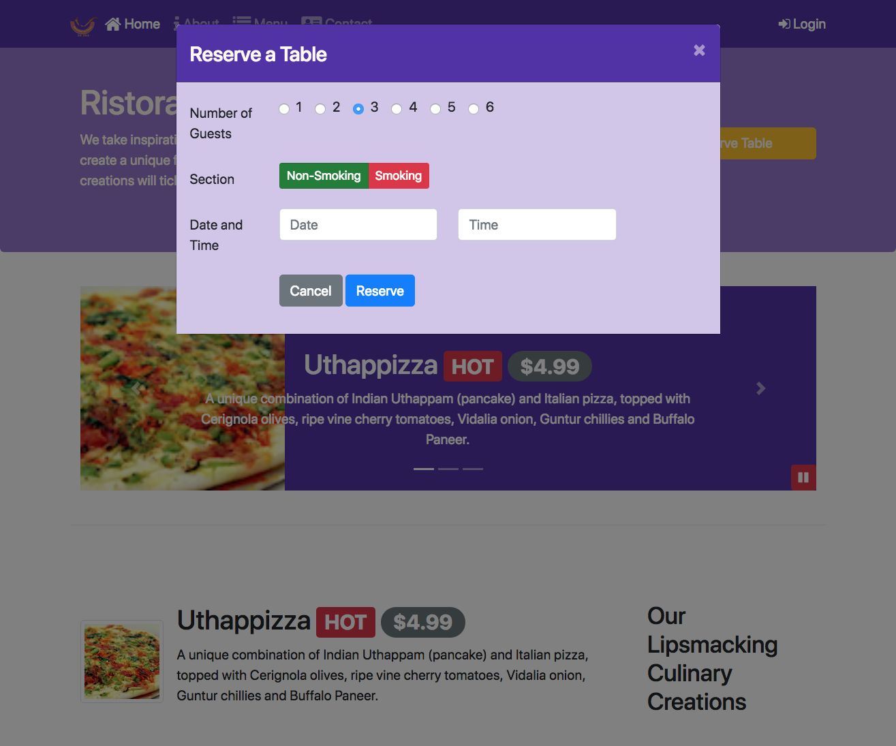

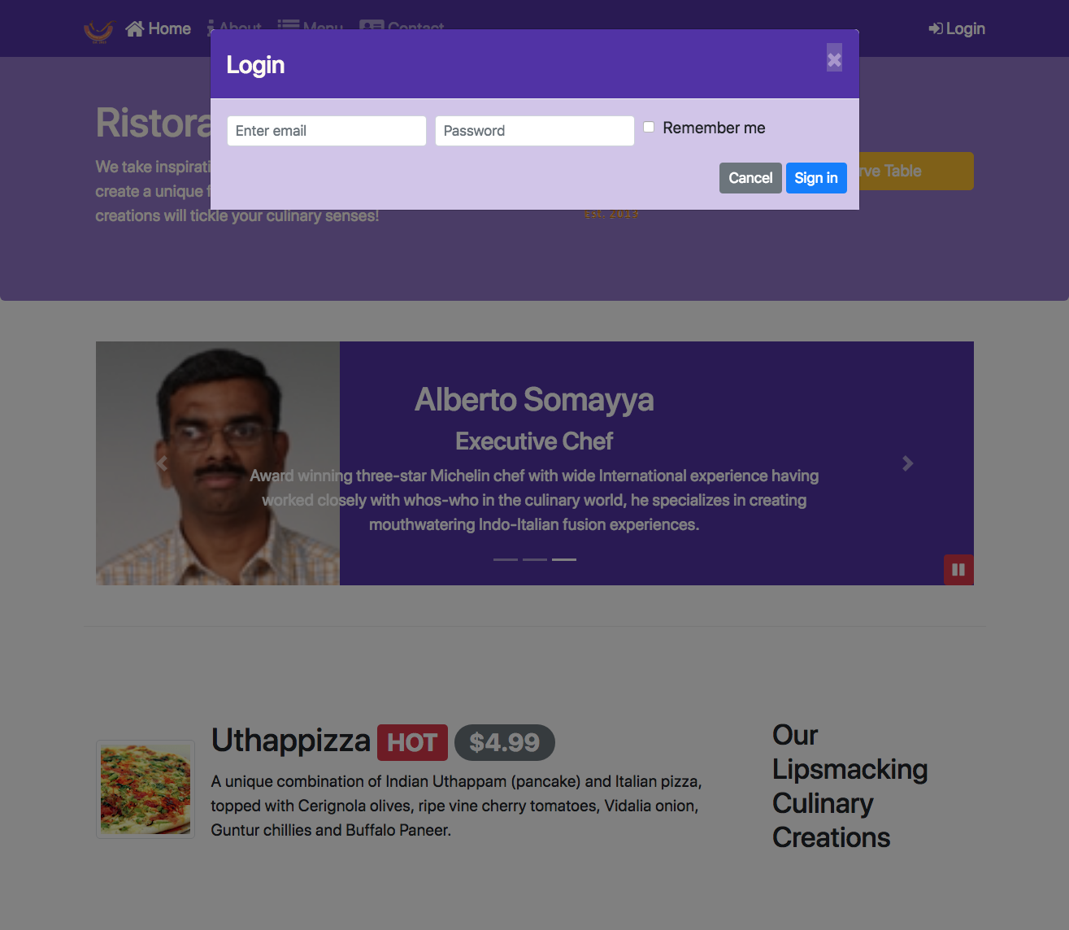

**Submission**

* You should submit the updated index.html file and styles.scss with all the tasks completed. A reviewer should easily be able to take your files and substitute it into their own web project and see it working correctly.

### Review criteria

**less**

Upon completion of the assignment, your submission will be reviewed based on the following criteria:

Task 1:

* The data-* attributes have been removed from the Reserve Table button.
* The data-* attributes have been removed from the Login link.

Task 2:

* Appropriate JavaScript code has been added to the page to trigger the Reserve Table modal.
* The Reserve Table button has been appropriately updated to enable the triggering of the modal.

Task 3:

* Appropriate JavaScript code has been added to the page to trigger the Login modal.
* The Login link has been appropriately updated to enable the triggering of the modal.

Task 4:

* Appropriate SCSS code has been added to styles.scss to set the modal header and body background colors appropriately.
* Set up the modal header text color to floralwhite.
* Set up the close button color to floralwhite.

# **Assignment 4: Additional Resources**

### Screenshots





### Bootstrap Documentation

* [Modals](http://getbootstrap.com/docs/4.0/components/modal/)
* [Modal Methods](http://getbootstrap.com/docs/4.0/components/modal/#methods)